Monitoring / On-Call Approval Form

Employee Name: Nikunj Adhaduk _

Manager Name: Vlad Rabenok .
Monitoring Hours
Date of Monitoring (mm/dd/yyyy) | Project | Reason | Number of Hours
TOTAL

On-Call Payment
Dates On-Call (mm/dd/yyyy – mm/dd/yyyy) | # of Weeks | Rate
5/12/2024 – 5/18/2024 | 1 | 200
5/26/2024 – 6/1/2024 | 1 | 200
6/2/2024 – 6/8/2024 | 1 | 200
6/16/2024 – 6/22/2024 | 1 | 200
6/30/2024 – 7/6/2024 | 1 | 200
7/21/2024 – 7/27/2024 | 1 | 200
7/28/2024 – 8/3/2024 | 1 | 200
8/4/2024 – 8/10/2024 | 1 | 200
TOTAL |  | 1600
Approvals
Employee Signature: 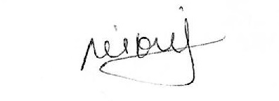 | Date:  Aug 9, 2024
Manager Signature: | Date:  Aug 9, 2024

Please submit to Payroll once approved.

Description
Date of Monitoring | Hours | Reason
May 14, 2024 | 2 | Varacode issue and manual run and deployment support at night
May 31^{st,} 2024  June 3rd, 2024 | 3 | Cineplex after hour escalation and high priority issue where cineplex was not receiving any event due to job failure at databricks
June 21, 2024 | 1 | Data lake job failure and support to ITOPS team after hours to scale the VM and get the job running
July 6, 2024  July 24, 2024 | 1.5 | Sobeys urgent prod issue and after-hours support where they are keep getting 401  July 24 deployment support for DE
July 29, 2024 | 2.5 | Hotfix deployment for cineplex after issue cause by .Net upgrade and I had to do config work to create slot and deploy the production code manually to that slot and switching the APIM traffic after hours to that slot
Aug 2, 2024 | 1.5 | B2C production issue and after-hours support where incorrect username and password activity stop creating so had to fix the B2C custom policy and support on deployment

